Experiment 1: Regular Expressions in Python

Aim
To write a Python program that demonstrates the use of Regular Expressions to match and search for patterns in text.

Algorithm
- Import the re module.
- Accept a string from the user.
- Define a regular expression pattern.
- Search the pattern in the given text using re.search().
- If the pattern is found, display the matched text.
- Otherwise, display that no match was found.

Python Code
import re

text = input("Enter a sentence: ")
pattern = input("Enter the word to search: ")

match = re.search(pattern, text)

if match:
print("Pattern found:", match.group())
else:
print("Pattern not found.")

Sample Input
Enter a sentence: Hello I am Studying Natural Language Proccessing
Enter the word to search: Natural

Sample Output
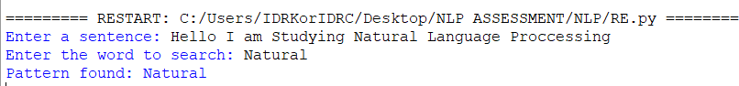

Result
Thus, the Python program to demonstrate Regular Expression pattern matching and searching was executed successfully.

Experiment 2: Finite State Automaton (Strings Ending with 'ab')

Aim
To implement a basic Finite State Automaton (FSA) in Python that recognizes strings ending with "ab".

Algorithm
- Read a string from the user.
- Initialize the automaton to the start state.
- Process each character one by one.
- Change states based on the input character.
- After processing all characters, check whether the automaton is in the accepting state.
- Display whether the string is accepted or rejected.

Python Code
states = {"q0", "q1", "q2"}
alphabet = {"a", "b"}
transition = {
"q0": {"a": "q1", "b": "q0"},
"q1": {"a": "q1", "b": "q2"},
"q2": {"a": "q1", "b": "q0"}
}
initial_state = "q0"
final_states = {"q2"}
n = int(input("Enter number of strings to test: "))
for i in range(n):
string = input(f"\nEnter String {i+1}: ")
current_state = initial_state
path = [current_state]
valid = True
for symbol in string:
if symbol not in alphabet:
print("Invalid Input Symbol:", symbol)
valid = False
break
current_state = transition[current_state][symbol]
path.append(current_state)
if valid:
print("Transition Path:")
print(" → ".join(path))

if current_state in final_states:
print("Accepted")
else:
print("Rejected")

Sample Input
Enter a string: abab

Sample Output
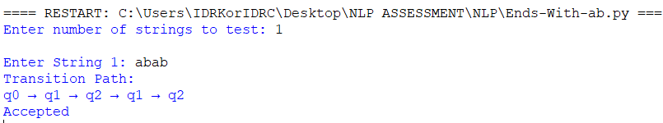

Result
Thus, the Python program implementing a Finite State Automaton for recognizing strings ending with "ab" was executed successfully.

Experiment 3: Morphological Analysis using NLTK

Aim
To perform morphological analysis using the NLTK library in Python by applying stemming and lemmatization.

Algorithm
- Import the required NLTK libraries.
- Download the required NLTK datasets.
- Read a word from the user.
- Apply Porter Stemmer to obtain the stem.
- Apply WordNet Lemmatizer to obtain the lemma.
- Display both the stemmed and lemmatized forms.

Python Code
import nltk
from nltk.stem import PorterStemmer, WordNetLemmatizer

nltk.download('wordnet')

stemmer = PorterStemmer()
lemmatizer = WordNetLemmatizer()

word = input("Enter a word: ")

print("Stemmed Word:", stemmer.stem(word))
print("Lemmatized Word:", lemmatizer.lemmatize(word))

Sample Input
Enter a word: Natural

Sample Output
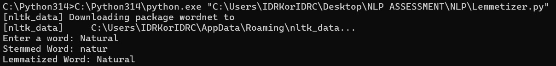

Result
Thus, the Python program for performing morphological analysis using the NLTK library was executed successfully.

Experiment 4: Finite State Machine for Morphological Parsing

Aim
To implement a Finite State Machine (FSM) for morphological parsing that generates plural forms of English nouns using Python.

Algorithm
- Define a function to generate plural forms of nouns.
- Check whether the noun ends with s, x, z, ch, or sh and add "es".
- Check whether the noun ends with y preceded by a consonant and replace "y" with "ies".
- Otherwise, add "s" to the noun.
- Store a list of sample words.
- Display the singular and plural forms.

Python Code
# Finite State Machine for Morphological Parsing
# Generates plural forms of English nouns

def generate_plural(noun):

# State q0 (Start State)
if noun.endswith(("s", "x", "z", "ch", "sh")):
# Transition to q1
plural = noun + "es"

elif noun.endswith("y") and len(noun) > 1 and noun[-2].lower() not in "aeiou":
# Transition to q2
plural = noun[:-1] + "ies"

else:
# Transition to q3
plural = noun + "s"

return plural

# Test words
words = ["cat", "dog", "bus", "box", "church",
"dish", "baby", "city", "toy", "book"]

print("Singular\tPlural")
print("------------------------")

for word in words:
print(f"{word:10}\t{generate_plural(word)}")

Sample Input
Words:
cat
dog
bus
box
church
dish
baby
city
toy
book

